Stop USFS Plans to Eliminate Devil’s Garden Wild Horse Herd

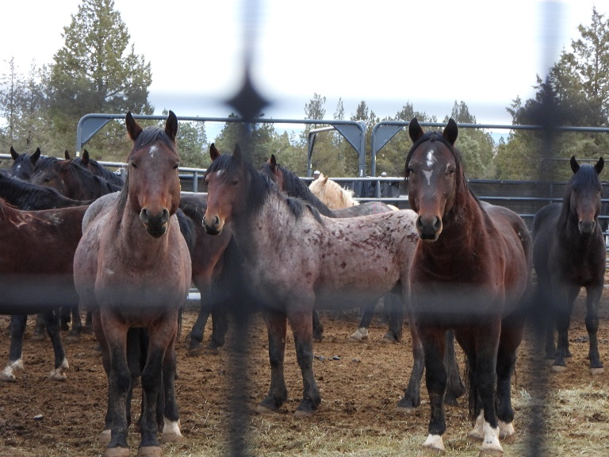

- The Devil’s Garden Plateau Wild Horse Territory (DGPWHT) is the largest Territory managed by the United States Forest service (USFS) in terms of acreage and number of horses.

- The Devil’s Garden wild horse herd was California’s largest wild horse herd.

- The USFS allows only 206-402 wild horses on the 258,000-acre DGPWHT, but it authorizes up to 3,700 cows and 2,900 sheep to graze for pennies per month.

- Since 2018, to placate ranching interests and maintain high levels of livestock grazing, the USFS has removed over 3,100 wild horses by inhumane and expensive helicopter roundups. Deaths and injuries are common; each roundup costs American taxpayers over $1 million.

- A 2024 census of the Devil’s Garden wild horses shows a dramatic and unexplained decline in population. In 2023, there were 1,339 horses including 43 foals; in the fall, 240 horses were removed. Now there are just 723 horses in this federally designated wild horse habitat.

- Since October 28th, the latest helicopter roundup has captured over 300 of the 500 horses targeted for removal from the DGPWHT. If successful, this would leave only 223 horses, a dangerously low number.

- The USFS has a long history of partnering with local ranchers, such as the Modoc Farm Bureau, to develop management plans for the DGPWHT that scapegoat wild horses for range land damage while ignoring the impacts of decades of overgrazing by private livestock.

- A proposed 2024 Territory Management Plan could result in the end of the Devil’s Garden wild horse herd because it prioritizes more roundups and the use of GonaCon, a fertility control vaccination known to cause sterility in mares. It also eliminates valuable acreage in the Middle Section of the DGPWHT.

- To save the Devil’s Garden wild horses for future generations, the proposed 2024 Territory Management Plan must be withdrawn and replaced with a new management plan that
- increases the number of wild horses permitted to live on the DGPWHT;
- replaces helicopter roundups and GonaCon with cost-effective, scientifically proven, and humane alternatives, such as PZP fertility control and range land improvements;
- reduces private livestock grazing; and
- restores the Middle Section.

For more information, email info@chwha.org

